**NEURAL NETWORK RESULTS**

Notes:

* When predicting properties, the order of the labels for the confusion matrix are

1. Smoothness
2. Thickness
3. Warmth
4. Flexibility
5. Softness

* When predicting properties, the macro F1 score was used as the data was balanced (same number of observations for each property)

**(1) Estimating the PROPERTY based on available data:**

* Chance classification accuracy: 20% (1/5)
* Used Leave One Participant Out CV

**MODEL 1: MODEL WITH 3 LINEAR FEATURES (USED ALL 180 FEATURES AS INPUT)**

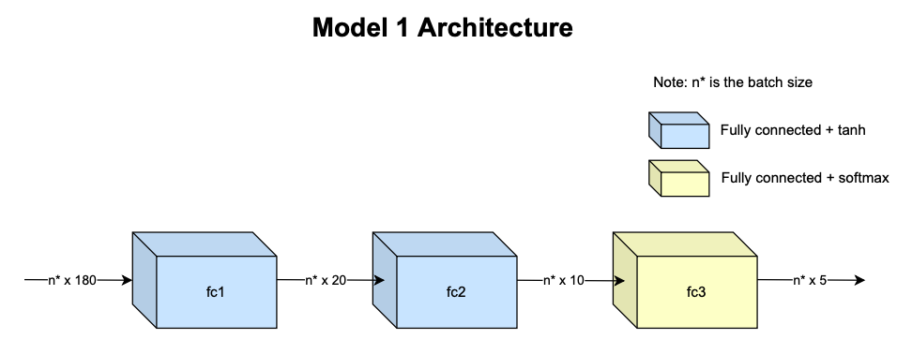

**MODEL 1a: lr = 0.005, num epochs = 75**

|  |  |  |  |
| --- | --- | --- | --- |
| **Confusion matrix** | **Average Micro F1 score** | **Average Macro F1 score** | **Overall accuracy** |
| [[100 53 31 56 12]  [ 42 80 32 59 39]  [ 64 60 40 57 31]  [ 35 32 14 138 33]  [ 43 52 26 82 49]] | 0.32 | 0.26 | 32.3% |

|  |  |  |  |  |
| --- | --- | --- | --- | --- |
| **Participant left out** | **Confusion matrix** | **Micro F1 score** | **Macro F1 score** | **Classification accuracy** |
| 1 | [[15 3 0 0 0]  [ 8 9 1 0 0]  [17 1 0 0 0]  [ 4 12 2 0 0]  [ 4 14 0 0 0]] | 0.27 | 0.15 | 26.67% |
| 2 | [[ 1 0 0 17 0]  [ 0 6 0 12 0]  [ 0 18 0 0 0]  [ 0 0 0 18 0]  [ 0 1 0 17 0]] | 0.28 | 0.16 | 27.78% |
| 3 | [[11 0 1 6 0]  [ 4 1 8 5 0]  [ 2 0 3 13 0]  [ 1 0 0 17 0]  [ 3 2 7 6 0]] | 0.36 | 0.27 | 35.56% |
| 4 | [[ 5 0 13 0 0]  [ 0 9 4 1 4]  [ 1 5 6 1 5]  [ 0 2 0 13 3]  [ 0 1 6 3 8]] | 0.46 | 0.47 | 45.56% |
| 5 | [[ 8 0 7 0 3]  [ 0 1 0 0 17]  [ 5 0 8 0 5]  [ 0 0 0 9 9]  [ 0 0 0 0 18]] | 0.49 | 0.46 | 48.89% |
| 6 | [[ 6 2 0 6 4]  [ 0 7 0 5 6]  [ 0 7 1 3 7]  [ 1 0 0 14 3]  [ 1 1 0 13 3]] | 0.34 | 0.32 | 34.44% |
| 7 | [[ 5 13 0 0 0]  [ 0 12 0 0 6]  [ 2 11 0 0 5]  [ 0 10 0 0 8]  [ 0 5 0 0 13]] | 0.33 | 0.25 | 33.33% |
| 8 | [[ 4 1 4 8 1]  [ 1 1 9 5 2]  [ 8 2 4 2 2]  [ 2 0 5 10 1]  [ 1 0 3 9 5]] | 0.27 | 0.25 | 26.67% |
| 19 | [[ 3 10 5 0 0]  [ 0 8 4 6 0]  [ 0 5 8 5 0]  [ 0 1 0 15 2]  [ 0 11 1 6 0]] | 0.38 | 0.33 | 37.78% |
| 21 | [[18 0 0 0 0]  [18 0 0 0 0]  [18 0 0 0 0]  [18 0 0 0 0]  [18 0 0 0 0]] | 0.2 | 0.07 | 20.00% |
| 22 | [[8 4 1 1 4]  [5 4 3 3 3]  [3 1 5 3 6]  [2 1 2 6 7]  [3 3 4 6 2]] | 0.28 | 0.28 | 27.78% |
| 23 | [[ 0 14 0 4 0]  [ 0 5 0 12 1]  [ 5 3 0 10 0]  [ 0 2 0 16 0]  [ 1 8 0 9 0]] | 0.23 | 0.13 | 23.33% |
| 24 | [[14 4 0 0 0]  [ 6 9 3 0 0]  [ 3 7 5 2 1]  [ 7 3 5 3 0]  [11 2 5 0 0]] | 0.34 | 0.29 | 34.44% |
| 25 | [[ 2 2 0 14 0]  [ 0 8 0 10 0]  [ 0 0 0 18 0]  [ 0 1 0 17 0]  [ 1 4 0 13 0]] | 0.3 | 0.21 | 30.0% |

**MODEL 1b: lr = 0.005, num epochs = 150**

|  |  |  |  |
| --- | --- | --- | --- |
| **Confusion matrix** | **Average Micro F1 score** | **Average Macro F1 score** | **Overall accuracy** |
| [[113 48 35 38 18]  [ 51 88 25 49 39]  [ 69 56 45 53 29]  [ 45 34 22 120 31]  [ 50 44 42 65 51]] | 0.33 | 0.26 | 33.1% |

|  |  |  |  |  |
| --- | --- | --- | --- | --- |
| **Participant left out** | **Confusion matrix** | **Micro F1 score** | **Macro F1 score** | **Classification accuracy** |
| 1 | [[15 0 3 0 0]  [13 5 0 0 0]  [17 0 1 0 0]  [ 7 8 2 1 0]  [ 4 7 6 1 0]] | 0.24 | 0.17 | 24.44% |
| 2 | [[ 0 7 4 4 3]  [ 0 14 0 0 4]  [ 0 18 0 0 0]  [ 0 0 1 16 1]  [ 0 10 0 6 2]] | 0.36 | 0.26 | 35.56% |
| 3 | [[16 0 1 1 0]  [ 2 5 3 8 0]  [ 2 3 2 11 0]  [ 0 0 0 18 0]  [ 4 1 5 8 0]] | 0.46 | 0.37 | 45.56% |
| 4 | [[ 7 0 11 0 0]  [ 1 7 4 1 5]  [ 5 1 7 2 3]  [ 0 1 1 9 7]  [ 1 0 5 2 10]] | 0.44 | 0.46 | 44.44% |
| 5 | [[12 4 1 0 1]  [ 0 10 0 0 8]  [ 6 5 2 0 5]  [ 0 1 0 8 9]  [ 0 0 0 0 18]] | 0.56 | 0.52 | 55.56% |
| 6 | [[ 0 7 3 6 2]  [ 0 10 0 5 3]  [ 0 12 1 1 4]  [ 0 2 0 13 3]  [ 0 1 2 12 3]] | 0.3 | 0.23 | 30.0% |
| 7 | [[ 0 9 9 0 0]  [ 0 8 10 0 0]  [ 0 1 17 0 0]  [ 0 8 7 0 3]  [ 0 3 13 0 2]] | 0.3 | 0.19 | 30.0% |
| 8 | [[ 4 0 1 13 0]  [ 2 1 1 12 2]  [ 9 1 3 4 1]  [ 2 1 2 13 0]  [ 0 0 1 16 1]] | 0.24 | 0.2 | 24.44% |
| 19 | [[ 0 6 0 1 11]  [ 0 0 0 5 13]  [ 0 0 0 6 12]  [ 0 0 0 14 4]  [ 0 5 0 2 11]] | 0.28 | 0.19 | 27.78% |
| 21 | [[18 0 0 0 0]  [17 0 0 1 0]  [18 0 0 0 0]  [18 0 0 0 0]  [18 0 0 0 0]] | 0.2 | 0.07 | 20.0% |
| 22 | [[ 7 9 1 0 1]  [ 1 14 1 0 2]  [ 0 10 4 1 3]  [ 1 8 4 1 4]  [ 2 10 3 0 3]] | 0.32 | 0.29 | 32.22% |
| 23 | [[14 2 0 2 0]  [ 5 2 1 8 2]  [ 6 1 0 10 1]  [ 4 0 2 12 0]  [ 8 1 1 7 1]] | 0.32 | 0.24 | 32.22% |
| 24 | [[14 3 1 0 0]  [ 7 6 5 0 0]  [ 5 4 8 1 0]  [13 2 3 0 0]  [11 1 6 0 0]] | 0.31 | 0.23 | 31.11% |
| 25 | [[ 6 1 0 11 0]  [ 3 6 0 9 0]  [ 1 0 0 17 0]  [ 0 3 0 15 0]  [ 2 5 0 11 0]] | 0.3 | 0.23 | 30.0% |

**MODEL 2: MODEL WITH 3 LINEAR Layers (USED ONLY EMG FEATURES AS INPUT – 48 FEATURES)**

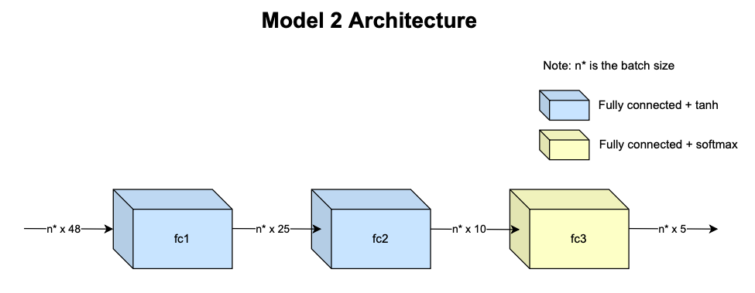

|  |  |  |  |
| --- | --- | --- | --- |
| **Confusion matrix** | **Average Micro F1 score** | **Average Macro F1 score** | **Overall accuracy** |
| [[ 99 23 37 80 13]  [ 75 25 26 100 26]  [ 73 24 46 85 24]  [ 30 25 39 130 28]  [ 42 30 45 116 19]] | 0.25 | 0.17 | 25.32% |

|  |  |  |  |  |
| --- | --- | --- | --- | --- |
| **Participant left out** | **Confusion matrix** | **Micro F1 score** | **Macro F1 score** | **Classification accuracy** |
| 1 | [[ 8 5 5 0 0]  [ 7 7 1 3 0]  [16 0 2 0 0]  [ 0 9 1 8 0]  [ 2 10 1 5 0]] | 0.28 | 0.24 | 27.78% |
| 2 | [[ 0 5 0 13 0]  [ 0 2 0 16 0]  [ 0 18 0 0 0]  [ 0 1 0 17 0]  [ 0 4 0 14 0]] | 0.21 | 0.1 | 21.11% |
| 3 | [[17 1 0 0 0]  [ 5 9 0 3 1]  [10 0 2 6 0]  [ 1 9 0 6 2]  [ 7 9 0 1 1]] | 0.39 | 0.32 | 38.89% |
| 4 | [[ 0 0 0 16 2]  [ 0 0 0 18 0]  [ 0 0 0 18 0]  [ 0 0 0 17 1]  [ 0 0 0 18 0]] | 0.19 | 0.06 | 18.89% |
| 5 | [[ 0 0 5 13 0]  [ 0 0 0 18 0]  [ 0 0 3 15 0]  [ 0 0 0 18 0]  [ 0 0 0 18 0]] | 0.23 | 0.12 | 23.33% |
| 6 | [[ 6 2 10 0 0]  [ 8 0 10 0 0]  [ 9 0 9 0 0]  [ 2 2 14 0 0]  [ 0 0 18 0 0]] | 0.17 | 0.1 | 16.67% |
| 7 | [[12 0 6 0 0]  [14 1 1 0 2]  [14 0 4 0 0]  [ 9 0 3 5 1]  [ 4 0 0 11 3]] | 0.28 | 0.25 | 27.78% |
| 8 | [[17 0 1 0 0]  [14 0 4 0 0]  [17 0 1 0 0]  [ 7 0 5 6 0]  [ 4 0 10 4 0]] | 0.27 | 0.18 | 26.67% |
| 19 | [[ 9 0 6 0 3]  [ 3 0 0 0 15]  [ 1 0 1 0 16]  [ 0 0 0 0 18]  [ 4 0 5 0 9]] | 0.21 | 0.16 | 21.11% |
| 21 | [[ 0 0 1 11 6]  [ 0 0 0 10 8]  [ 0 0 0 12 6]  [ 0 0 0 14 4]  [ 0 0 0 12 6]] | 0.22 | 0.12 | 22.22% |
| 22 | [[12 2 3 0 1]  [ 9 2 7 0 0]  [ 3 2 12 0 1]  [ 3 2 11 1 1]  [ 6 4 8 0 0]] | 0.3 | 0.22 | 30.0% |
| 23 | [[ 0 8 0 9 1]  [ 0 4 0 14 0]  [ 0 4 0 14 0]  [ 0 1 0 16 1]  [ 0 3 0 15 0]] | 0.22 | 0.12 | 22.22% |
| 24 | [[18 0 0 0 0]  [15 0 3 0 0]  [ 3 0 12 2 1]  [ 8 1 5 4 0]  [15 0 3 0 0]] | 0.38 | 0.28 | 37.78% |
| 25 | [[ 0 0 0 18 0]  [ 0 0 0 18 0]  [ 0 0 0 18 0]  [ 0 0 0 18 0]  [ 0 0 0 18 0]] | 0.2 | 0.07 | 20.0% |

**MODEL 3: MODEL WITH AN LSTM LAYER + LINEAR FEATURES (USED ALL 180 FEATURES AS INPUT**

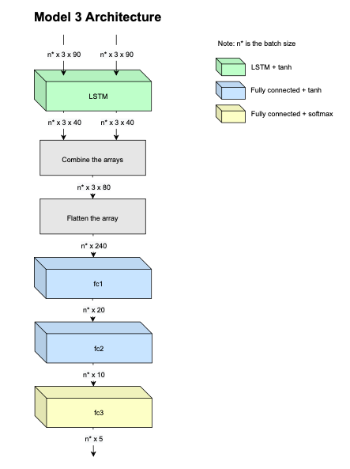

|  |  |  |  |
| --- | --- | --- | --- |
| **Confusion matrix** | **Average Micro F1 score** | **Average Macro F1 score** | **Overall accuracy** |
| [[28 8 33 14 1]  [23 7 37 16 1]  [26 6 27 23 2]  [14 6 29 30 5]  [18 6 37 20 3]] | 0.23 | 0.12 | 22.62% |

|  |  |  |  |  |
| --- | --- | --- | --- | --- |
| **Participant left out** | **Confusion matrix** | **Micro F1 score** | **Macro F1 score** | **Classification accuracy** |
| 1 | [[3 3 0 0 0]  [3 2 1 0 0]  [2 4 0 0 0]  [2 0 4 0 0]  [2 1 3 0 0]] | 0.17 | 0.12 | 16.67% |
| 2 | [[3 0 1 2 0]  [2 0 2 1 1]  [6 0 0 0 0]  [0 0 0 6 0]  [1 0 1 3 1]] | 0.33 | 0.25 | 33.33% |
| 3 | [[0 0 6 0 0]  [0 0 6 0 0]  [0 0 3 3 0]  [0 0 3 3 0]  [0 0 6 0 0]] | 0.2 | 0.14 | 20.0% |
| 4 | [[4 0 2 0 0]  [0 0 4 2 0]  [2 0 0 4 0]  [0 0 0 6 0]  [0 0 2 4 0]] | 0.33 | 0.24 | 33.33% |
| 5 | [[0 0 6 0 0]  [0 0 6 0 0]  [0 0 6 0 0]  [0 0 6 0 0]  [0 0 6 0 0]] | 0.2 | 0.07 | 20.0% |
| 6 | [[0 0 0 6 0]  [0 0 0 6 0]  [0 0 0 6 0]  [0 0 0 6 0]  [0 0 0 6 0]] | 0.2 | 0.07 | 20.0% |
| 7 | [[6 0 0 0 0]  [6 0 0 0 0]  [6 0 0 0 0]  [6 0 0 0 0]  [6 0 0 0 0]] | 0.2 | 0.07 | 20.0% |
| 8 | [[6 0 0 0 0]  [6 0 0 0 0]  [6 0 0 0 0]  [3 2 0 1 0]  [5 0 1 0 0]] | 0.23 | 0.13 | 23.33% |
| 19 | [[0 0 6 0 0]  [0 0 6 0 0]  [0 0 6 0 0]  [0 0 4 0 2]  [0 0 6 0 0]] | 0.2 | 0.07 | 20.0% |
| 21 | [[0 0 6 0 0]  [0 0 6 0 0]  [0 0 6 0 0]  [0 0 6 0 0]  [0 0 6 0 0]] | 0.2 | 0.07 | 20.0% |
| 22 | [[5 0 0 0 1]  [6 0 0 0 0]  [4 0 0 0 2]  [3 0 0 0 3]  [4 0 0 0 2]] | 0.23 | 0.13 | 23.33% |
| 23 | [[0 0 6 0 0]  [0 0 6 0 0]  [0 0 6 0 0]  [0 0 6 0 0]  [0 0 6 0 0]] | 0.2 | 0.07 | 20.0% |
| 24 | [[1 5 0 0 0]  [0 5 0 1 0]  [0 2 0 4 0]  [0 4 0 2 0]  [0 5 0 1 0]] | 0.27 | 0.19 | 26.67% |
| 25 | [[0 0 0 6 0]  [0 0 0 6 0]  [0 0 0 6 0]  [0 0 0 6 0]  [0 0 0 6 0]] | 0.2 | 0.07 | 20.0% |

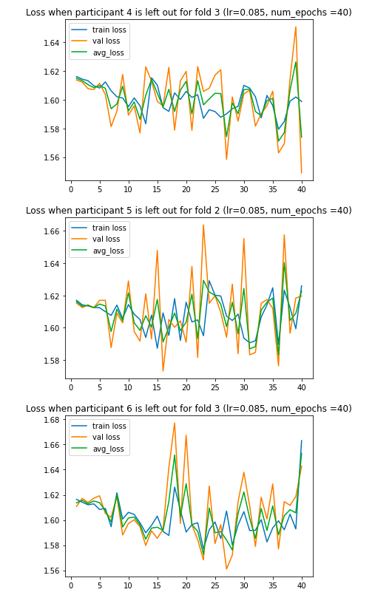

**MODEL 4: MODEL WITH AN LSTM LAYER + LINEAR FEATURES (USED ONLY EMG FEATURES AS INPUT – 48 FEATURES)**

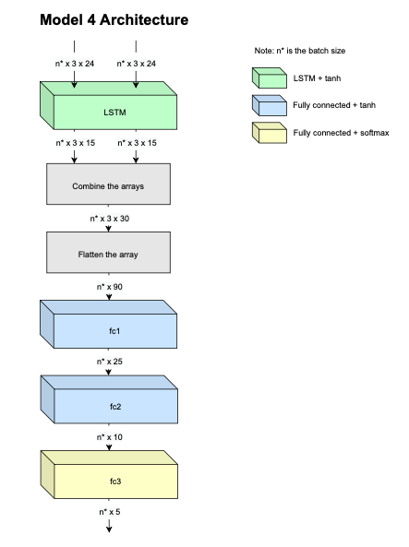

|  |  |  |  |
| --- | --- | --- | --- |
| **Confusion matrix** | **Average Micro F1 score** | **Average Macro F1 score** | **Overall accuracy** |
| [[15 26 12 13 18]  [ 9 13 15 32 15]  [18 19 16 17 14]  [ 6 8 11 35 24]  [10 11 11 33 19]] | 0.23 | 0.15 | 23.33% |

|  |  |  |  |  |
| --- | --- | --- | --- | --- |
| **Participant left out** | **Confusion matrix** | **Micro F1 score** | **Macro F1 score** | **Classification accuracy** |
| 1 | [[6 0 0 0 0]  [3 0 0 0 3]  [6 0 0 0 0]  [1 0 0 0 5]  [3 0 0 0 3]] | 0.3 | 0.17 | 30.0% |
| 2 | [[0 0 2 2 2]  [0 0 3 2 1]  [6 0 0 0 0]  [0 1 1 1 3]  [0 1 1 3 1]] | 0.07 | 0.06 | 6.67% |
| 3 | [[1 5 0 0 0]  [0 1 0 5 0]  [3 0 1 2 0]  [0 0 0 6 0]  [1 1 0 4 0]] | 0.3 | 0.23 | 30.0% |
| 4 | [[0 0 0 2 4]  [0 0 0 6 0]  [0 0 0 5 1]  [0 0 0 6 0]  [0 0 0 6 0]] | 0.2 | 0.08 | 20.0% |
| 5 | [[0 3 2 1 0]  [0 0 0 6 0]  [0 2 0 4 0]  [0 0 0 6 0]  [0 0 0 6 0]] | 0.2 | 0.08 | 20.0% |
| 6 | [[0 0 0 1 5]  [0 0 0 2 4]  [0 1 0 1 4]  [0 0 0 0 6]  [0 0 0 0 6]] | 0.2 | 0.08 | 20.0% |
| 7 | [[2 3 1 0 0]  [2 1 3 0 0]  [2 1 3 0 0]  [1 2 2 0 1]  [0 0 4 2 0]] | 0.2 | 0.16 | 20.0% |
| 8 | [[0 6 0 0 0]  [0 6 0 0 0]  [0 6 0 0 0]  [0 3 1 2 0]  [0 3 1 1 1]] | 0.3 | 0.23 | 30.0% |
| 19 | [[0 5 0 1 0]  [0 3 0 3 0]  [0 2 1 3 0]  [0 0 0 6 0]  [0 4 0 2 0]] | 0.33 | 0.23 | 33.33% |
| 21 | [[0 0 0 0 6]  [0 0 0 0 6]  [0 0 0 0 6]  [0 0 0 0 6]  [0 0 0 0 6]] | 0.2 | 0.07 | 20.0% |
| 22 | [[1 0 2 2 1]  [0 0 6 0 0]  [0 1 4 0 1]  [0 0 3 2 1]  [0 0 3 2 1]] | 0.27 | 0.23 | 26.67% |
| 23 | [[0 3 0 3 0]  [0 1 1 4 0]  [0 5 0 1 0]  [0 2 0 4 0]  [0 2 0 4 0]] | 0.17 | 0.09 | 16.67% |
| 24 | [[5 1 0 0 0]  [4 1 0 0 1]  [1 1 1 1 2]  [4 0 0 0 2]  [6 0 0 0 0]] | 0.23 | 0.18 | 23.33% |
| 25 | [[0 0 5 1 0]  [0 0 2 4 0]  [0 0 6 0 0]  [0 0 4 2 0]  [0 0 2 3 1]] | 0.3 | 0.2 | 30.0% |

